Q 1 Write a query that produces all pairs of salespeople who are living in the same city. Exclude combinations of salespeople with themselves as well as duplicate rows with the order reversed.

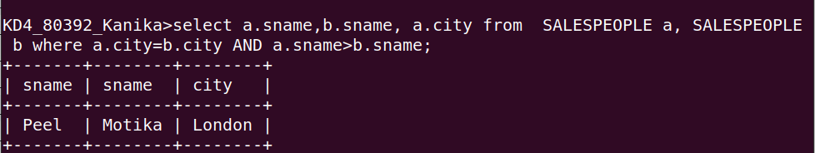

Q 2 Write a query that produces the names and cities of all customers wih the same rating and Hoffman.

